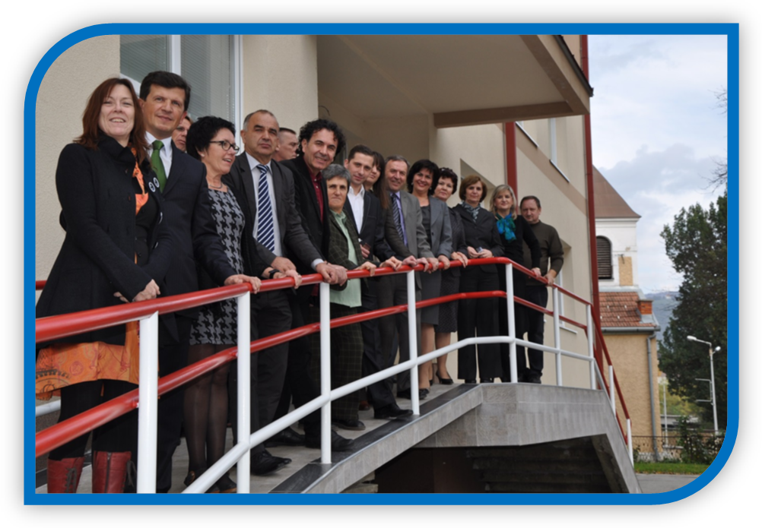
Municipal International Cooperation Guidelines 2013


Preamble
“Local authorities form a vital bridge between national governments, communities and citizens and will have a critical role in a new global partnership.” A New Global Partnership: Eradicate Poverty and Transform Economies Through Sustainable Development, The Report of the High-Level Panel of Eminent Persons on the Post-2015 Development Agenda
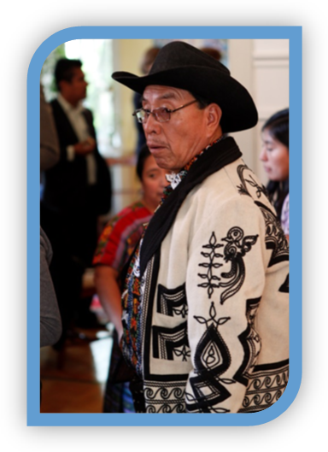
Capacitated local governments can contribute substantially to achieving development goals through service delivery, yet they are largely ignored by development actors. NGO activities are often directed towards providing services locally, such as in education and health, but this can create an accountability vacuum and weaken the relationship between people and local government. Instead, Municipal International Cooperation (MIC) encourages capacity-building which enables local authorities to fully deliver on their mandate and provide appropriate, relevant and sustainable services to their citizens.
Norway has a well-developed and efficient system of local self-government and Norwegian municipalities possess experience and knowledge that can be of interest and benefit to municipalities in other parts of the world. Through MIC, KS and its members aim to contribute to capacity-building in partner municipalities in order to help achieve devolution and the transfer of power, responsibilities and resources to the local level and as such support work towards a reduction of global poverty. The programme is financed by the Ministry of Foreign Affairs and Norad and complies with relevant Norwegian government policy and established monitoring and reporting requirements.

Contents
Preamble 1
Contents 2
Introduction 3
Programme Goal 3
Programme purposes 3
Strategic Goals for the Norwegian Partner 4
Attracting, Keeping and Developing Human Resources 5
Good Publicity for the Municipality 5
Spreading International Involvement 5
General Principles for Collaboration 5
A Results-Based Apporach 7
Implementation 8
Risk Assessment 8
Code of Ethics 9
Reporting 9
Hints and Tips 10
Success Factors 10
Local Knowledge 10
Learning From Past Projects 10
Useful documents 11
Appendix 1 - Annual programme cycle 12

Introduction
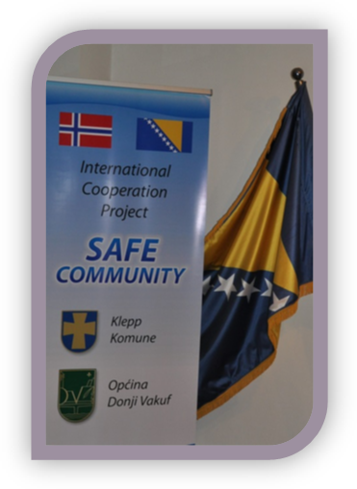
The Municipal International Cooperation programme provides a framework for mutual capacity-building between Norwegian municipalities and a limited number of municipalities in Guatemala, East Africa, the Balkans and Eastern Europe in terms of mutual prioritised municipal tasks. The cooperation must be in line with the programme goal and no more than two of the four programme purposes.
Cooperation should contribute to improving the capacity of local government employees and councillors, and activities can focus on local government administrative processes, service delivery, financial mechanisms, efficiency, accountability and transparency. A requirement is that the activities address core municipal tasks in both collaborating municipalities. By core tasks it is meant statutory municipal duties which are determined locally, led by municipal employees and fall within ordinary municipal budgets.
It is also recommended that MIC programme participation follows a municipal council decision, or forms part of a municipal international strategy, and is as such properly anchored in municipal affairs. KS will request documentation of municipal commitment when appraising MIC applications.

Programme Goal
The overall programme goal is to improve municipal governance and service delivery. Building solid public institutions, implementing transparency in all processes at the local level and fostering accountability will:
- Contribute to efficient government
- Lead to stronger public trust in local authorities
- Result in a more open dialogue between authorities and citizens
- Strengthen popular participation in local democracy

Programme purposes
- Efficient local service delivery
- Environmental concerns in local plans
- Trust, transparency and participation in local politics
- Transparency and accountability in local government
Thus, the programme shall contribute to the strengthening of local service delivery and democratic participation as well as strengthen international understanding within Norwegian municipalities through the exchange of experiences. The vision is that capacity-building within local government and among politicians and employees leads to a strong and efficient local government sector that addresses the needs of its citizens – in both Norway and the partner country.

Strategic Goals for the Norwegian Partner
Many of the reported benefits to the Northern municipality arising from MIC can be described as ‘softer’, or less technical, than those in the Southern municipalities. But that is not to say that they are of lesser value. Indeed, these benefits – such as teamwork and leadership and management skills – are often undervalued and rarely expressed in the objectives of the partnership. It is important that this type of learning is brought to a more conscious level, and made more explicit and clear in the project goals.
Examples of these soft learning outcomes include professional revitalisation and a renewed emphasis on responding to citizen needs, listening to users and creating trust. In addition, personal learning effects such as raising awareness of global inequality and increased cultural understanding can be classified as soft outcomes.
“bumping up against difference … can stimulate our curiosity, our drive to learn, and our ability to actively try to enter each other’s experiences and perspectives”
(Wyss-Flamm 2002: 150)
MIC partnerships can have the effect of making participants much more aware of the relationship between the social and the technical, and challenge participants to unpick many of the standard assumptions they make about their work or profession. Indeed, MIC can create a space for comparative analysis whereby differences between partners can be seen as triggers for learning rather than obstacles. Being challenged to reconsider why one works as one does forces one to reflect on issues previously taken for granted and makes one address problems from new perspectives. Furthermore, there is also the possibility that practices from the South can be adapted in the North, such as how to better include underrepresented groups in the political process, or how to organise council meetings in a more efficient manner.
However, the concept of mutuality of output can be seen in terms of more than mere learning for the Norwegian partner. Indeed, wider benefits exist for the municipal administration that are not directly related to knowledge and learning, but which can be of a more strategic and political-organisational perspective.

Attracting, Keeping and Developing Human Resources
MIC is an exciting international project which potentially increases job satisfaction and motivation in the local administration. In addition, it promotes the municipality as an attractive employer which places an emphasis on personal and professional development that moves beyond the local. Furthermore, by placing the municipality in a wider context, MIC can be used as a means to educate and enlighten citizens, officials and politicians at the local level in terms of international understanding, improved foreign language proficiency (English or Spanish) and enhanced negotiating capabilities. In an increasingly international society, such competencies may be seen as a valuable requirement in the workplace.
“Professional skills were reinforced … Having to go with a blank sheet is very challenging and exciting. I think it was the highlight of their careers.”
(Johnson and Wilson 2009: 14)

Good Publicity for the Municipality
Through municipal partnerships, one can potentially gain valuable experience and knowledge that can be used intentionally to achieve good publicity. This can be used strategically to promote participating municipalities as ‘international municipalities’ with global identities and which are interested, experienced in and competent at working internationally. Furthermore, this can be used to promote the municipality as a good place to live and work.

Spreading International Involvement
MIC can be used as a basis for spreading international involvement and offering opportunities for citizens, organisations and businesses to take part in international cooperation. By establishing such multiple institutional ties and a common platform for international understanding and global awareness locally, one can widen the scope of learning possibilities beyond the municipal sector. Indeed, by initiating an international strategy and establishing multiple ties – also outside city hall – it would be easier to legitimise MIC as a political priority and obtain the backing of citizens.

General Principles for Collaboration
Collaboration through MIC is in line with the four shared principles for achieving common goals set out in the Busan Partnership for Effective Development Co-operation: a) ownership of development priorities by developing countries; b) focus on results; c) inclusive development partnerships; and d) transparency and accountability to each other. MIC principles are as follows:
Programme sustainability: The results of the programme should continue to provide long-term impact to the partner municipality after the ending of the programme
Coherence with the plans of partner countries: The project activities should be coordinated and in line with the partner countries’ own plans for good governance and poverty eradication at national and sub-national level.
Recipient responsibility: The non-Norwegian partner should lead the prioritisation, planning and implementation of the co-operation activities, and partners should not enter into activities that may counteract national government strategies. Recipient responsibility also implies that all documentation must be in a language understood by the non-Norwegian partner (e.g. English or Spanish).
Support from other actors: It is of utmost importance that the Norwegian municipality receives information regarding other bilateral and multilateral donors that support the partner – and that the support is harmonised and coordinated.
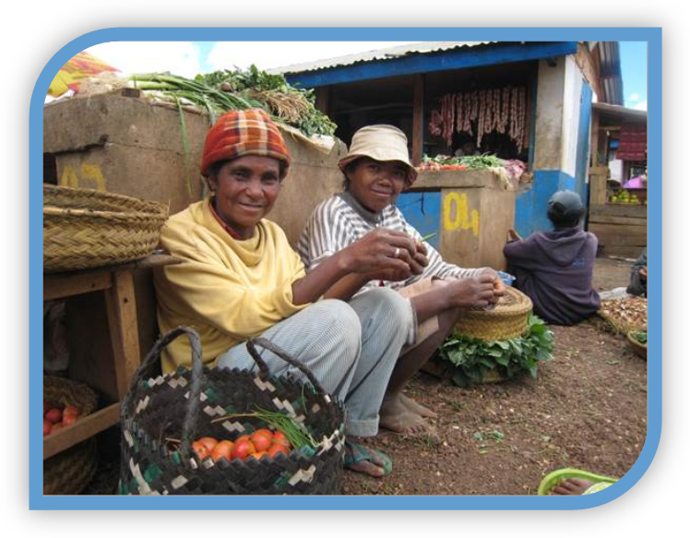
National mobilisation: The participating Norwegian municipality should have a strategy for its development activities and should be able to mobilise its council, staff and citizens beyond financial support to the project.
Utilise own competence: The partners should make clear that there is a relationship between their areas of competence and the activities of the programme.

A Results-Based Apporach
“If you don’t know where you are going, any road will lead you there”
Results-based management (RBM) is about choosing a goal, deciding on a method for achieving it, checking progress and making adjustments, as required, in order to succeed. Hence, a results-based approach involves shifting attention away from inputs, activities and processes and instead focusing on benefits; in other words, from what you have done to what you have achieved (Norad 2008: 9).
It is generally accepted that outcomes represent the most important result-level in results management. Outcomes are the intended, immediate effects on the target groups, and may stem from factors both within and beyond the control of the programme. Even so, the purpose of defining clear outcomes is for managers to stay focused on what ultimately matters: the effects of their interventions on people and systems (Norad 2008: 10).
Norad’s Results Management in Norwegian Development Cooperation: A Practical Guide (2008) is an excellent tool for planning, implementing and evaluating development projects and is recommended reading for all MIC municipalities. It is available online – see link at the end of this document.

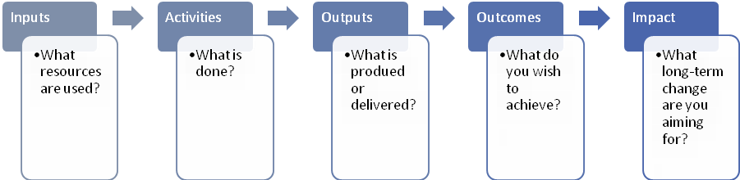
Results Level
Short-term Long-term

Figure 1: The results chain (after Norad 2008)

In expressing objectives, aim for precision; the more precise the objective, the higher the measurability. This will help avoid ‘double’ objectives, whereby two objectives on different levels of the results chain are combined. Hence, objectives should be ‘SMART’ (Norad 2008: 15):
- Specific
- Measureable
- Achievable
- Relevant
- Time-bound
Having defined the objectives, indicators – and explicit targets for each indicator – are needed to assess progress towards the desired results. Indicators may be quantitative or qualitative, but should be limited in number and restricted to key indicators; fewer indicators may sometimes give a stronger message. It is important to keep in mind that the indicators must be based on valid and reliable data, and should be possible to monitor with simple data collection methods. A key element here is to align planning, reporting and monitoring criteria, and ensure that they fit with existing systems in the partner nation.
After the three years of the cooperation project, it will be difficult to know what you and your partner have achieved if you don’t know where you started. Therefore, it is crucial that you know the baseline values of the indicators before project activities are implemented. A baseline study will help provide a snapshot of the situation at project start-up and act as a point from which progress can be tracked. Using a limited number of realistic, workable indicators will improve survey quality and allow for an effective and efficient use of resources.

Implementation
Institutional cooperation under the MIC programme involves a commitment between two partners. Many tasks and obligations relating to project implementation or partnership management will be known or are self-explanatory. It is, nevertheless, recommended that partners clarify roles, expectations and commitments at the start of the cooperation through the signing of a partnership agreement contract. A template can be provided by KS, and copies of signed contracts should be shared with KS.
It is a contract requirement that the scope and objectives of the project be formulated within the overall framework of the MIC programme. In addition, partners should commit to an annual meeting to review project progress and to discuss work plans and budgets, as well as possible amendments to the contract. It can also be an important learning arena where partners discuss both project-specific issues and more general matters of relevance for local government such as service provision, outsourcing, and the roles or relationships between elected councillors and municipal employees.

Risk Assessment
As part of the planning phase, arguably before any agreement is reached, the risks of a potential MIC partnership need to be considered. Risks are closely related to results and should consequently be analysed against the results framework of a project. The core of risk management is to identify, analyse and react to internal or external factors that might impede implementation or have a negative influence on the achievement of results (Norad 2008: 18).
The first step in risk management is to identify the risk factors. Early identification will allow for alteration of the design, organisation or management of the project. However, the identification of the risks is not sufficient: they need to be analysed in terms of the probability of their occurance and the consequences they can be expected to have for the project.
The next step is risk response, or risk mitigation. The approach is to accept the presence of risks and plan accordingly. Management strategies can then be considered in order to bring the factors under control. These will tend to focus on:
- Reducing the probability that a risk factor will occur by changing the design or implementation of the plan, or introducing mitigating measures.
- Reducing the consequences if the risk factor occurs.
However, the further one progresses along the results chain, the less control the project will have over these risk factors and the ability to bring risk under control becomes increasingly difficult. In many cases, neither of the two options above are possible and so continuing with the project should be questioned. If not rejected, the tolerance of high risk factors should always be documented. Given that controlling risks is often not possible, the best alternative is to monitor the status of the risk assumptions, giving greatest attention to those with the highest risk rating and taking corrective actions when necessary.

Code of Ethics
It is important that the methods used in to achieve MIC goals are ethical and appropriate, and that attitudes and actions support human rights and democracy. Each MIC participant must thus develop a Code of Ethics to be submitted to KS when first applying to join the programme. KS can advise on its development, and its toolkit on ethics, social responsibility and anticorruption can be used as a starting point.

Reporting
In order for KS to be able to comply with its duties and responsibilities in respect to funding partners (Norad and MFA), participating municipalities must provide KS with annual reports in an agreed format by DATE. Annual reports contain a narrative part in free text emphasising how project outputs contribute to project outcomes, as well as a financial report in a standard format. The accounts need not be audited before the end of the project, thus projects lasting for several years will have their accounts audited after the final year. The audit shall be performed by an authorised, independent auditor and carried out in accordance with the current international auditing standard IAS 805. The auditor’s report must express an opinion with reasonable assurance. In addition to certifying that the financial statements have been prepared in accordance with the described accounting principles, the auditor shall confirm that the relevant terms of agreement for the treatment of the funds have been adhered to. Further information can be found in the document Guidelines for the audit of grants from the Norwegian Ministry of Foreign Affairs.
KS will consolidate an annual report and programme narrative for submission to Norad/MFA along with audited accounts by DATE each year.

Hints and Tips

Success Factors
From previous projects, it is clear that an important success factor has been openness and humbleness. More specifically, this refers to the willingness to listen and learn and is arguably the foundation for building sustainable relations of trust. Furthermore, openness can be seen in relation to the idea of a ‘two-way flow of information’ which makes mutual understanding and learning more likely.
Another success factor is recognising that MIC projects are a form of peer-to-peer partnership: It helps when the individual participants are professional equals who can share information and experiences at the same level.

Local Knowledge
Mutuality is a crucial factor in the success or failure of international collaborations, and a major sticking point is that types of knowledge are often valued differently. Frequently – and arguably unconsciously – the northern partner values their own knowledge of professional practice more highly than southern partners’ knowledge of context. However, it is this understanding of context and coded social practice that is essential in creating a successful project. Indeed, the recognition of the value of local knowledge goes hand-in-hand with an attitude of openness and willingness: northern municipalities that enter into cooperation in this spirit have tended to get the most out of the fresh perspectives provided by collaboration.
The moral case for partnership is of course strong, and there are many positive things to be said in favour of development assistance, but two qualifiers are necessary. Firstly, while acts of charity are seen as good and right things to do, one needs to be careful that their consequences might end up doing more harm than good. Secondly, there is the challenge to ensure that aspects of dominance or inequality are not being perpetuated, but are rather being replaced by new relationships and forms of engagement. By recognising the value of local knowledge, it is hoped that these problems are avoided.

Learning From Past Projects
Although political embeddedness is common in MIC projects, with municipalities considering development cooperation to be a ‘good thing’, there is often a lack of political priority. MIC projects are frequently at the bottom of the political agenda, and thus time and resources are not necessarily allocated to the extent needed to make the projects successes or spread the benefits more widely throughout the municipality. This is also linked to a results-oriented leadership: leaders are role models in demonstrating attitudes and behaviours that are essential for the success of the programme. As a result, the focus on outcomes must be supported from the top political level.
Thus, although there has been a lot of individual learning for the individuals directly involved in MIC projects, knowledge transfer to the rest of the organisation has often been difficult to achieve. Hence, it is important to create a learning culture by which individual learning experiences can be scaled up to sustainable organisational change: there is a need to provide project exposure to a wide range of people so that the partnership is ‘owned’ by the whole organisation and not seen as a perk for a few individuals. However, this information-spreading requires time and resources, and this may be difficult if the partnership is not prioritised – and thus is intrinsically linked to political priority.
In addition, given that international cooperation is not a core municipal task, there also needs to be local popular support. A key element of this is widening the scope of information-spreading out of house and into the community, but arguably the critical factor is that there should be some visible mutual gains from the partnership. As with development assistance more generally, citizens have a right to ask “what am I getting for my taxes?” and so benefits need to be identified and disseminated to the public.

Useful documents
Johnson, H. and G. Wilson (2009) Learning and mutuality in municipal partnerships and beyond: a focus on northern partners. Habitat International 33(2): 210-217.
Norad (2008) Results Management in Norwegian Development Cooperation: A practical guide. Oslo: Norad. http://www.norad.no/no/resultater/publikasjoner/publikasjon/_attachment/119718 (Accessed 13.06.2013)
Norwegian Ministry of Foreign Affairs (????) Guidelines for the audit of grants from the Norwegian Ministry of Foreign Affairs. ?
Tranberg Bjørndal, M. et al. (2012) “Has it been worth it?”: The significance of participating in a MIC programme as seen from a Norwegian municipality’s perspective. Unpublished report. http://www.sv.uio.no/iss/om/samarbeid/prosjektforum/Tidligere%20prosjekter/rapporter/2012/rapport-ks-mic.pdf (Accessed 13.06.2013).
United Nations (2013) A New Global Partnership: Eradicate Poverty and Transform Economies Through Sustainable Development: The Report of the High-Level Panel of Eminent Persons on the Post-2015 Development Agenda. New York: United Nations Publications.

Appendix 1 - Annual programme cycle
Procedure | Norad deadline | Norwegian Ministry of Foreign Affairs (NMFA) deadline | Comments
Annual application from partnerships to KS | 1 October | 15 January | To NMFA only for programme application. Annual application n.a. to NMFA.
KS programme application to Norad/NMFA | 1 November | 15 February | To NMFA only for programme application. Annual application n.a. to NMFA.
Allocation of funds from KS to the partnerships | 1 March &  1 October | 1 October | Two annual instalments from Norad, but only one from NMFA.
Annual progress report with audited accounts from the partnerships to KS | 15 April | 1 September
Network meetings and other capacity-building initiatives | TBA | TBA

